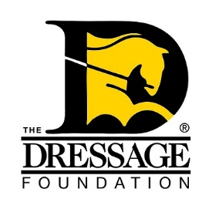
The Dressage Foundation's

Evie Tumlin Memorial Fund

for Region 9 Adult Amateurs
Grant Application

Applications will only be accepted through the online form. The application form and all required attachments must be received by The Dressage Foundation’s office on or before March 1st to be considered. Attachments must be in Word, Excel, or PDF format.
We encourage you to review this application and gather all materials prior to starting the online application process. Once you start, your work cannot be saved. Helpful tip - Type your answers into a Word document, save, and then copy and paste your answers into the form.
Applicant Information:
Name
Address
Phone Number
Email Address
Are you a U.S. Citizen or Permanent Resident?
Are you an Adult Amateur?
I understand that it is my responsibility to know the rules governing amateur status. I certify that I am an amateur within the meaning of USEF Article GR 1306.
Name of Horse you are applying to train with
Age of Horse
Breed of Horse
Do you own or lease the horse? How long have you been working with it? If leased, please provide documentation from USDF or USEF. How long have you leased this horse?
Please list equestrian organizations in which you are currently a member (including local clubs).
Proposed Educational/Training Event (in one sentence)
Proposed Event/Training Dates
General Information:
Do you ride dressage, eventing, or both?
Provide a brief summary of your dressage and/or eventing experience, including level(s) ridden, awards received, and educational events attended. (Max 250 words)
With a grant from this Fund, what do you specifically want to achieve and what are your plans to achieve those goals? (Max 250 words)
Proposed Training/Educational Event:
Describe what educational event you plan to attend with this Grant. Include the name of the program/instructor, date, and location. Training or event can start no sooner than two months after the application deadline date. (Max 250 words)
Which goals are you expecting to achieve with participation in this educational event? (Max 100 words)
Community Involvement:
In what ways have you been involved in your local dressage community? Examples include hosting open clinics, donating time/resources, volunteer work, etc. (max 100 words)
Financial Information:
Provide a detailed budget of how you plan to use the $1,000 grant.
Please explain why you need financial assistance from The Dressage Foundation. (Max 250 words)
What current and past financial assistance/sponsorship have you received, including grants or awards from The Dressage Foundation?
How is this grant going to help you achieve your goals?
Recommendation Letter:
Attach one letter of recommendation. The letter should speak to your desire to continue your dressage/eventing education, as well as to how you support your dressage/eventing community through volunteer work.
Signature Page:
Please upload your signed Signature Page.
Important Notes
You will be notified that the application has been received within two business days. If you do not receive email confirmation (please check your spam folder!) that your application has been received, please call our office at (402) 434-8585. Additionally, if you have any questions regarding the application, feel free to contact us. After the grant selection committee has made its final decision, all applicants will be notified. Thank you!

