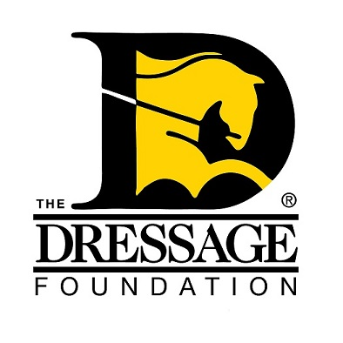
The Dressage Foundation’s

Sally Swift Fund Grant Application

You can use this form to gather and save your answers, but the online application found on our website must be completed and received by TDF’s at least 75 days prior to your event for your application to be considered. Please contact us at (402) 434-8585 or info@dressagefoundation.org if you have questions.

Organization Name:
Contact Person:
Position held in Organization:
Street Address:
City, State, Zip:
Phone:
Email:

Instructional Program

Describe your event. Is this a camp, seminar, symposium, lecture, etc.?

What is the daily schedule?

How will this event program help the participants?

If applicable, list the level of riders who will be participating in this program (do not include auditors).

Event Details

Date of event:

How many riders will attend?
How many auditors will attend?

Fee per rider:
Fee per auditor:

Location - name of facility, type of facility:

Instructor's name and qualifications

Other

How will you advertise this activity?

Who is the desired audience?

If your group is awarded a grant from The Dressage Foundation, how will you promote that TDF is a supporter of this program?

Other information regarding your clinic that you think the Selection Committee will find useful in reviewing this application.

Financials

What financial help will your Organization give to this clinic?

Provide a budget of expenses and income.

Amount requested from The Dressage Foundation (maximum amount $1,000):

IMPORTANT NOTES:
The Dressage Foundation's Sally Swift Fund will grant funding only once in each calendar year to a non-profit organization. The amount of the grants can vary depending on the need and request of the applicants, but typically range from $500 - $1,000.

The complete application and all required attachments must be submitted through the online application form at www.dressagefoundation.org, at least 75 days prior to the start of the event. You will be notified that the application has been received within 2 business days.

If you do not receive email confirmation that your application has been received, please call our office at (402) 434-8585. Additionally, if you have any questions regarding the application, feel free to contact us. Thank you!

